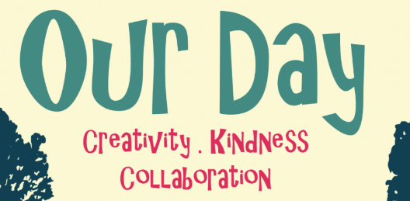

 | 8.00 - 9.00 | 9.15 - 10.15 | 10.30 - 11.30 | 11.30 - 12.30 | 12.30 - 13.00 | 13.15 - 14.15 | 14.15 - 14.45 | 14.45 - 15.30
Group One - Yellow | Set Up | Arts Award - Bag Printing | Collaborative bushcraft activity | Arts Award – What is Community? P4C enquiry | Dinner | Arts Award – local artist case study | Final session back in classroom to evaluate and review Arts Award | Clean Up
Group 2 - Red | Set Up | Arts Award – local artist case study | Arts Award - Bag Printing | Collaborative bushcraft activity | Dinner | Arts Award – What is Community? P4C enquiry | Final session back in classroom to evaluate and review Arts Award | Clean Up
Group 3 - Blue | Set Up | Arts Award – What is Community? P4C enquiry | Arts Award – local artist case study | Arts Award - Bag Printing | Dinner | Collaborative bushcraft activity | Final session back in classroom to evaluate and review Arts Award | Clean Up
Group 4 - Green | Set Up | Collaborative bushcraft activity | Arts Award – What is Community? P4C enquiry | Arts Award – local artist case study | Dinner | Arts Award - Bag Printing | Final session back in classroom to evaluate and review Arts Award | Clean Up

NB: The workshop time allows five minutes for change-over between activities.

For any further information please contact Paula Moses on 07914 853919 paula@permanenteducation.org

